**COMPARATIVE ANALYSIS OF CRUDE OIL AND GAS PRODUCTION USING VARIOUS MACHINE LEARNING MODELS**

***Project report submitted to***

***the Career Point University, Kota***

***For the partial fulfilment for the award of the degree of***

**Bachelor of Computer Application (BCA)**

***By***

**Saloni Sharma**

*K23252*

***Under the Supervision of***

Dr. Garima Tyagi

*(Professor)*



**SCHOOL OF COMPUTER APPLICATION AND TECHNOLOGY CAREER POINT UNIVERSITY, KOTA**

May, 2025

# CERTIFICATE

This is to certify that the work contained in the project report entitled **“Comparative Analysis of Crude Oil and Gas Production Using Various Machine Learning Models”**, submitted by **Saloni Sharma (UID No.: K23252)** for the award of the degree of **Bachelor of Computer Application** to the **Career Point University, Kota,** is a record of Bonafide research works carried out by her under my direct supervision and guidance.

I considered that the project report has reached the standards and fulfilling the requirements of the rules and regulations relating to the nature of the degree. The contents embodied in the project report have not been submitted for the award of any other degree or diploma in this or any other university.

**Date:** 23/05/2025 Signature of Supervisor

**Place:** Kota Dr. Garima Tyagi

(Professor)

School of Computer Applications and Technology

# DECLARATION

I certify that

1. The work contained in the project report is original and has been done by myself under the supervision of my supervisor.
2. The work has not been submitted to any other Institute for any degree or diploma.
3. I have conformed to the norms and guidelines given in the Ethical Code of Conduct of the Institute.
4. Whenever I have used materials (data, theoretical analysis, and text) from other sources, I have given due credit to them by citing them in the text of the project report and giving their details in the references.
5. Whenever I have quoted written materials from other sources and due credit is given to the sources by citing them.
6. From the plagiarism test, it is found that the similarity index of whole project report within 25% and single paper is less than 10 % as per the university guidelines.



**Date:** 23/05/2025 **Saloni Sharma**

**Place:** Kota **KID. No.: K23252**

# ACKNOWLEDGEMENTS

I am sincerely grateful to all those who supported and guided me throughout the successful completion of this project, ***" Comparative Analysis of Crude Oil and Gas Production Using Various Machine Learning Models”.*** First and foremost, I express my heartfelt gratitude to my project supervisor, **Dr. Garima Tyagi Ma’am**, for their valuable insights, constant encouragement, and unwavering support at every stage of this work. Their expert guidance has been instrumental in shaping the direction and outcome of this project.

I extend my sincere thanks to the **Head of Department, Dr. Garima Tyagi Ma’am**, and all the faculty members of the **Department of Computer Application and Technology** for providing me with the necessary academic resources and a motivating learning environment throughout my course.

I would also like to thank the lab assistants and technical staff for their assistance during the practical implementation phase. Their support was crucial in testing and deploying the application.

My appreciation goes to my fellow classmates and friends who shared ideas and provided feedback that helped refine the project further. Finally, I thank my family for their moral support and encouragement during the development of this project.

This work is a reflection of everyone’s contribution, and I am truly thankful to each one of them.



**SALONI SHARMA**  
 **(K23252)**

# ABSTRACT

The global energy landscape is undergoing rapid transformation, with a growing emphasis on efficient and accurate forecasting of petroleum and gas production to support decision-making in exploration, extraction, and distribution. This project titled “Comparative Analysis of Crude Oil and Gas Production Using Various Machine Learning Models” presents a systematic study on how data-driven models can be used to predict production rates more accurately. Traditional statistical methods often fail to capture nonlinear dependencies and complex interrelationships among influencing parameters. In contrast, Machine Learning (ML) offers adaptable algorithms that learn from historical patterns and provide better prediction accuracy.

The dashboard is divided into key modules such as:

* **Static Analysis:** Upload a single file, filter, and visualize.
* **Dynamic Comparison:** Upload two datasets and compare them visually.
* **Download Engine:** Export filtered or visualized data in CSV or Excel formats.
* **Theme and Settings:** Apply dark mode, select chart themes, and save preferences.

This research incorporates multiple ML algorithms, namely Linear Regression, Random Forest, XGBoost, and LSTM (Long Short-Term Memory networks), and evaluates their performance on historical production data. A comparative analysis is conducted using accuracy metrics such as MAE, RMSE, and R² Score. The project also features a dual-page Streamlit dashboard — one for comparative analysis and another for dynamic visualization based on user-uploaded datasets. The findings contribute to more robust decision-making in the oil and gas sector and pave the way for future research into intelligent forecasting methods.

***Keywords:*** *Crude oil prediction, Gas production forecasting, Machine learning models, Linear Regression, Random Forest, XGBoost, LSTM, Comparative analysis, Production analytics, Energy data prediction.*

# LIST OF ABBREVIATIONS

**Abbreviation Description**

ML Machine Learning

ED Exploratory Data Analysis

API Application Programming Interface

CSV Comma Separated Values

DB Database

RMSE Root Mean Square Error

SRS Software Requirements Specification

UI/UX User Interface/User Experience

MAE Mean Absolute Error

R² Coefficient of Determination

LSTM Long Short-Term Memory

XGBoost Extreme Gradient Boosting

# LIST OF FIGURES

## Figure Number Page

**Figure 1:** Use Case Diagram 11

**Figure 2:** Streamlit Dashboard – File Upload Interface 31

**Figure 3:** Static Visualization – Actual vs Predicted Chart 32

**Figure 4:** Bar Chart Showing R2 Scores of ML Models 32

**Figure 6:** Bar Chart for Crude Oil Prediction using MAE 23

**Figure 7:** Bar Chart for Crude Oil Prediction using RMSE 33

**Figure 8:** Export Feature for CSV/Excel 33

# LIST OF TABLES

## Table Number Page

**Table 1**: Test Cases 26

**Table 2:** Test Report 30

**CONTENTS**

**Content Details Page No.**

**Certificate ii**

**Declaration iii**

**Acknowledgement iv**

**Abstract v**

**List of Abbreviations vi**

**List of Figures vii**

**List of Tables vii**

1. **Introduction 1**
   1. Project Profile . . . . . . . . . . . . . . . . . . . . . . . . . . . . . . . . . . . 1
   2. Overview . . . . . . . . . . . . . . . . . . . . . . . . . . . . . . . . . . . . . 1
   3. Motivation . . . . . . . . . . . . . . . . . . . . . . . . . . . . . . . . . . . . . . . . . 2
   4. Goal . . . . . . . . . . . . . . . . . . . . . . . . . . . . . . . . . . . . . . . . 2
2. **Initial System Study 4**
   1. Chapter Introduction . . . . . . . . . . . . . . . . . . . . . . . . . . . . . . . 4
   2. Drawbacks of the existing system . . . . . . . . . . . . . . . . . . . . . . . . 4
   3. Problem definition . . . . . . . . . . . . . . . . . . . . . . . . . . . . . . . . 5
   4. The proposed system . . . . . . . . . . . . . . . . . . . . . . . . . . . . . . . 6
   5. Scope of the system . . . . . . . . . . . . . . . . . . . . . . . . . . . . . . . . 6
   6. Scope of this project . . . . . . . . . . . . . . . . . . . . . . . . . . . . . . . 7
   7. System development approach . . . . . . . . . . . . . . . . . . . . . . . . . . 8
3. **Feasibility Analysis 9**
   1. Technical Feasibility . . . . . . . . . . . . . . . . . . . . . . . . . . . . . . . . . . . 9
   2. Operational Feasibility . . . . . . . . . . . . . . . . . . . . . . . . . . . . . . . . . 9
   3. Economic Feasibility . . . . . . . . . . . . . . . . . . . . . . . . . . . . . . . . . . 10
   4. LegalFeasibility . . . . . . . . . . . . . . . . . . . . . . . . . . . . . . . . . . . . 10
   5. ScheduleFeasibility . . . . . . . . . . . . . . . . . . . . . . . . . . . . . . . . . . . 10
4. **System Analysis 11**
   1. Introduction . . . . . . . . . . . . . . . . . . . . . . . . . . . . . . . . . . . . . . . . 11
   2. Use Case diagram …………………………………………………………………. 11
   3. Physical and behavioral aspects of the system ……………………………………….. 13
5. **Software Requirements Specifications 14**
   1. General Description ………………………………………………………………… 14
      1. Product Perspective 14
      2. Product Functions 14
      3. User Characteristics 15
      4. General Constraints 15
      5. Assumptions and Dependencies 15
      6. Functional Requirements 15
   2. External Interface Requirements 16
      1. User Interfaces 16
      2. Hardware Interfaces 16
      3. Software Interfaces 16
   3. Performance Requirements 16
   4. Design Constraints 16
      1. Standard Compliance 16
      2. Hardware Constraints 17
      3. Other Requirements 17
      4. Scope of this project 17
6. **System design 19**
   1. Introduction 19
   2. System Architecture 20
   3. Module Design 20
   4. Database Design 20
   5. Input Output Design 21
   6. Algorithm design 21
   7. Electronic Data Communication Design 21
   8. System Maintenance 21
   9. Other Alternatives Considered 22
7. **System Implementation 23**
   1. Hardware Components 23
   2. Software Environment 23
   3. System Development Platform 24
   4. Project Accomplishment Status 24
   5. Guidelines for Continuation 25
8. **System Testing 26**
   1. Test Plan . 26
   2. Test Cases 26
9. **Conclusion & Future Direction of Work 28**
   1. Conclusion 28
   2. Future Direction of work 28

**References 29**

1. **User Manual 30**
   1. Installation Manual 30
   2. Reference Manual 30
   3. Maintenance Manual 30
2. **Test Report 30**
3. **Input Output Formats 31**
   1. Input Forms in the New System 31
   2. Output Formats in the New System 31
4. **Screenshots 31**
5. **Source Code 35**
6. **Introduction**
   1. **Project Profile**

The project titled *“Comparative Analysis of Crude Oil and Gas Production Using Various Machine Learning Models”* focuses on analyzing and predicting the production rates of crude oil and natural gas using advanced computational approaches. In the contemporary energy sector, accurate production forecasts are essential for planning, decision-making, and maintaining energy supply chains. Traditional methods for such forecasting often rely on linear projections or manual analysis, which may not effectively capture complex patterns in data. With the rise of big data and ML, predictive models have gained popularity for their ability to handle large datasets and extract meaningful patterns.

This project explores the use of multiple machine learning algorithms including Linear Regression, Random Forest, and XGBoost to assess which model performs best in terms of accuracy and reliability. The data-driven approach of this project enhances decision-making processes for oil and gas companies and stakeholders. The analysis is implemented using Python and Streamlit, providing both a technical backend and a user-friendly dashboard for visualization.

* 1. **Overview**The increasing global demand for oil and natural gas necessitates more accurate and efficient methods for predicting their production. Forecasting petroleum and gas output is crucial for energy companies, government planning, supply chain logistics, and environmental monitoring. Traditionally, time series and statistical techniques have been employed for such forecasts, but they often fall short in handling non-linear patterns and dynamic changes in reservoir behavior. This project aims to address this gap by leveraging Machine Learning (ML) models to predict production trends using historical data. The models chosen — Linear Regression, Random Forest, XGBoost, and LSTM — represent a spectrum from basic to advanced techniques, enabling a broad comparison in terms of performance and accuracy. Each algorithm is trained and tested on datasets related to crude oil and gas production. The project also includes a Streamlit-based interactive dashboard that offers two primary functionalities: one page for comparing algorithm performances, and another for dynamically uploading datasets and visualizing relationships between selected columns. The end goal is to identify the most effective ML model for petroleum and gas forecasting, contributing to smarter energy management and operational planning.
  2. **Motivation**

The motivation behind this project stems from the growing necessity for energy resource optimization and better production forecasting in the oil and gas industry. As global energy demands continue to rise, efficient management of crude oil and natural gas production has become a top priority for both governmental and private entities. Inaccurate predictions can lead to resource mismanagement, financial losses, and logistical challenges in the energy supply chain.

Traditional statistical approaches often fail to capture the complex, nonlinear patterns found in petroleum and gas production data. This inspired the integration of machine learning (ML) techniques into the domain, given their ability to analyze large datasets, adapt to changing data trends, and produce more reliable forecasts. By comparing various ML algorithms—Linear Regression, Random Forest, XGBoost, and LSTM—this project seeks to uncover which models provide the best accuracy and performance in real-world datasets.

Moreover, the implementation of a user-friendly Streamlit dashboard motivates the idea of accessibility and interaction. It allows users to not only explore the comparative performance of algorithms but also upload and visualize their own datasets dynamically, making the solution versatile and practical. This motivation of combining accurate forecasting with user interactivity is what drives the development of this project.

* 1. **Goal**

The primary goal of this project is to conduct a comparative analysis of various machine learning algorithms for accurately predicting crude oil and gas production using historical datasets. As the oil and gas sector plays a vital role in the global economy, precise forecasting of production helps in better planning, decision-making, resource management, and reducing economic risk.

To achieve this, the project focuses on implementing and evaluating different machine learning models — specifically Linear Regression, Random Forest, XGBoost, and LSTM (Long Short-Term Memory) — and analyzing their performance based on prediction accuracy and error metrics like R² score, MAE (Mean Absolute Error), and RMSE (Root Mean Square Error).

Another significant goal is to create an interactive Streamlit dashboard with two main functionalities:

1. A Comparative Analysis Page that visually compares the performance of the above models.
2. A Dynamic Visualization Page that allows users to upload two datasets and generate comparative graphs based on column selection.

Through this dual-purpose platform, the goal is to bridge technical ML predictions with a simple, accessible interface for non-technical users — thereby ensuring that data scientists, engineers, researchers, and business analysts can all benefit from this predictive system. Ultimately, the aim is to deliver a comprehensive and practical solution that supports both experimentation and deployment in real-world scenarios.

1. **Initial System Study**
   1. **Chapter Introduction**

This chapter serves as the foundation for understanding the background, current challenges, and the need for improvement in the domain of crude oil and gas production prediction. It offers insights into the existing systems used for production forecasting and highlights their limitations in terms of accuracy, scalability, and adaptability. The chapter introduces the organization or context where the problem exists, presents a critical evaluation of the shortcomings in traditional forecasting approaches, and establishes the need for adopting data-driven solutions using machine learning techniques.

The chapter also formulates the core problem definition, which revolves around the inconsistent and often unreliable nature of existing prediction models for petroleum and gas production. Furthermore, it introduces the proposed system, which leverages a comparative approach involving multiple machine learning algorithms to identify the most efficient and accurate model. The scope of the system, both in terms of its real-world applicability and project limitations, is discussed to frame the boundaries of this research.

The section concludes by outlining the system development approach adopted, including the use of Python, machine learning libraries, and the development of a Streamlit dashboard. This chapter thus sets the stage for the design and implementation process by thoroughly analyzing the current scenario and establishing the rationale for the proposed system.

* 1. **Drawbacks of the existing system**

The traditional systems used for predicting crude oil and gas production primarily rely on statistical models, manual record-keeping, or rule-based forecasting methods. These systems often face several limitations that hinder their ability to deliver accurate, timely, and scalable insights in today’s data-driven world.

One of the major drawbacks is **limited accuracy**. Traditional methods fail to account for nonlinear relationships and complex interdependencies between variables like pressure, temperature, drilling depth, and time. As a result, their predictions often fall short when dealing with volatile markets or changing environmental conditions.

Another issue is **manual data processing**, which is time-consuming and prone to human error. Large datasets from sensors and field equipment can become overwhelming without automation and intelligent algorithms. These systems also struggle with **real-time data analysis**, which is crucial in modern petroleum operations for making prompt decisions.

Moreover, many existing systems are not flexible or adaptive. Once programmed, they can’t learn from new data or patterns. They also **lack visualization features**, making it difficult for decision-makers to interpret trends and forecasts effectively.

The absence of comparative analytics also limits their utility—users cannot easily determine which prediction technique performs best under various conditions. Overall, the current systems are **outdated, rigid, and inefficient**, especially in an era where artificial intelligence and machine learning can provide far superior results in both performance and usability.

* 1. **Problem definition**

In the petroleum industry, accurately predicting the production of crude oil and natural gas is essential for planning, decision-making, and resource optimization. However, the current methods used for forecasting production are outdated and lack the sophistication required to handle large volumes of data and nonlinear relationships between different influencing variables. These traditional systems often provide generalized predictions that fail to adapt to fluctuating operational parameters, leading to inefficient planning and resource management.

Moreover, there is a significant gap in comparing the effectiveness of various predictive models. Industry professionals have limited clarity on which machine learning algorithm offers the most accurate and reliable results for specific types of production datasets. This lack of comparative analysis leads to a trial-and-error approach rather than a data-driven strategy. The core problem addressed in this project is the **need for a robust, intelligent, and comparative analytical framework** that can accurately forecast petroleum production using multiple machine learning algorithms—namely Linear Regression, Random Forest, XGBoost, and LSTM. Additionally, there is a necessity for a user-friendly, interactive interface where users can **upload production datasets**, **run algorithm comparisons**, and **visualize results graphically**. This problem definition guides the development of a system that not only predicts but also evaluates and compares model performance to recommend the best-fit algorithm under given conditions.

* 1. **The proposed system**

To address the challenges identified in the problem definition, this project proposes the development of an intelligent, comparative analysis system for predicting crude oil and gas production using various machine learning models. The core idea of the system is to not only make predictions but also to analyze and compare the accuracy, reliability, and performance of different algorithms on real-world production datasets. The system includes four popular machine learning models: **Linear Regression**, **Random Forest**, **XGBoost**, and **LSTM (Long Short-Term Memory)**, each offering unique strengths in handling time-series and structured production data.

The proposed system is implemented using **Python** and deployed as an interactive **Streamlit web application**. It has two primary modules:

* Allow **Comparative Analysis Page** – where users upload a dataset, choose the target column, and run all models to compare metrics like R² Score, MAE (Mean Absolute Error), and RMSE (Root Mean Square Error) through intuitive bar charts.
* **Dynamic Visualization Page** – which allows uploading of two datasets to visualize and compare trends, statistics, or parameters side-by-side using interactive graphs.

The system is designed for scalability, modularity, and ease of use, allowing users from technical and non-technical backgrounds to make data-driven decisions. This modernized approach will help industries and researchers determine which algorithm performs best under specific data conditions and make accurate petroleum production forecasts with minimal manual intervention.

* 1. **Scope of the system**

The scope of this system lies in its ability to provide an advanced, data-driven framework for analyzing and predicting crude oil and gas production trends using machine learning models. It is particularly relevant to sectors such as energy production, petroleum engineering, environmental planning, and resource management, where accurate forecasting is critical for planning and decision-making. This project doesn’t just stop at making predictions — it allows users to compare multiple algorithms in real time and determine which performs best for a specific dataset.

The system is built to support flexible CSV-based input, making it adaptable to any time-series or structured dataset relevant to oil and gas production. Through the **Comparative Analysis Page**, users can experiment with four powerful models — Linear Regression, Random Forest, XGBoost, and LSTM — and visualize the comparative performance metrics. This assists in model selection based on dataset characteristics. The **Dynamic Visualization Page** expands the tool's utility by offering side-by-side analysis of two different datasets, such as crude oil and gas production data from different time periods or regions.

Additionally, the system is scalable and modular, meaning that new algorithms, datasets, or visualization features can easily be integrated in future updates. Its implementation in **Streamlit** ensures a user-friendly interface that is accessible even to non-technical users. The system contributes significantly toward data analytics in the energy sector and forms a base for further research and real-time deployment.

* 1. **Scope of this project**

The scope of this project, titled *"Comparative Analysis of Crude Oil and Gas Production Using Various Machine Learning Models"*, is centered on building a robust, interactive, and comparative framework for analyzing historical petroleum and gas production data using supervised machine learning techniques. The project is not just about applying algorithms — it offers a comprehensive approach to understanding which model performs best in real-world forecasting scenarios by comparing metrics like R², MAE, and RMSE across multiple models: **Linear Regression**, **Random Forest**, **XGBoost**, and **LSTM**. The system has been designed using Python and integrated into an intuitive **Streamlit dashboard** with two primary components. The first is the **Comparative Analysis Page**, which allows users to upload one dataset, select a target column, and evaluate the performance of all four models. The second is the **Dynamic Visualization Page**, which accepts two datasets and generates side-by-side visual comparisons of column-based data, helping users interpret similarities or trends between them.

This project can be extended across a variety of energy forecasting problems — from predicting demand to analyzing regional production variations. It supports future enhancements like real-time data fetching through APIs, model retraining on updated data, and adding more complex deep learning models. The system’s modularity, adaptability to any CSV-based dataset, and user-centric design make it useful not only in academic research but also in industrial applications where quick insights are critical.

* 1. **System development approach**

The development approach of this project follows a modular and iterative methodology, emphasizing clarity, reusability, and user interactivity. The project, *"Comparative Analysis of Crude Oil and Gas Production Using Various Machine Learning Models"*, uses a blend of **data science practices** and **software engineering principles** to ensure a robust and functional end product.

The process begins with **data collection and preprocessing**, where crude oil and gas production datasets are cleaned, null values handled, and feature selection is performed. After preparing the datasets, four machine learning models — **Linear Regression**, **Random Forest**, **XGBoost**, and **LSTM** — are implemented and trained on the data. Each model is evaluated using key regression metrics like **R² Score**, **Mean Absolute Error (MAE)**, and **Root Mean Squared Error (RMSE)**.

The project uses **Streamlit** as the frontend interface, allowing the creation of a dynamic dashboard with two key modules. The **first module** offers static comparative analysis on a single uploaded dataset, presenting users with model-wise visual comparisons. The **second module** enables dynamic data visualization by accepting two datasets and generating comparative graphs based on selected columns.

The development process is iterative — each stage is tested before progressing to the next. Libraries like **pandas, numpy, scikit-learn, xgboost**, and **keras** are utilized for model development, while **matplotlib** and **seaborn** support the visualizations. The modular design ensures each component (data preprocessing, modeling, dashboard UI) can be independently updated or scaled in the future.

1. **Feasibility Analysis**

Feasibility analysis is a critical phase in any project lifecycle. It determines whether the proposed system is practically implementable, financially viable, and technically achievable. This chapter evaluates the feasibility of this Machine Learning-based Crude Oil and Gas Production Prediction System from multiple perspectives — technical, operational, economic, legal, and schedule.

* 1. **Technical Feasibility**

The development of this project is technically feasible using modern and well-documented open-source tools. The technologies and tools used include:

* **Frontend & Backend:** Developed using Streamlit, which integrates both frontend and backend in a single Python-based framework.
* **Programming Language:** Python 3.10 or higher.
* **Machine Learning Libraries:**
* Scikit-learn for Linear Regression, Random Forest, and XGBoost
* Keras and TensorFlow for LSTM implementation
* **Visualization Tools:** Matplotlib, Plotly, Seaborn
* **Development Platform:** Jupyter Notebook / VS Code
* **Deployment Capability:** Can be run locally or hosted via platform like Streamlit Cloud.

All components used are open-source or have free usage tiers, making the system both accessible and scalable.

* 1. **Operational Feasibility**

This project solves a practical problem in the oil and gas domain—predicting future production values using machine learning. The system supports:

* User-friendly interface via Streamlit.
* Easy CSV uploads for real-world data input.
* Graphical comparison of ML models.
* Useful for students, researchers, and industry analysts.

The interface is simple and does not require technical knowledge, enabling users from various backgrounds to interact with it smoothly.

* 1. **Economic Feasibility**

This system is highly cost-effective due to the following reasons:

* All tools used (Python, Scikit-learn, Streamlit, etc.) are open-source.
* No special hardware is required—runs on any laptop with a modern OS and Python environment.
* Deployment, if needed, can be managed using **free hosting platforms** (Streamlit Cloud, Heroku, etc.)
* Ideal for academic institutions or small businesses with limited budgets.

Thus, the overall development and operational cost is minimal.

* 1. **Legal Feasibility**

This system adheres to legal and ethical standards:

* No personal user data is stored or collected.
* Login module (if used) can be integrated with role-based access using encrypted credentials.
* All datasets used (e.g., from Kaggle or open government portals) are publicly available and cited properly.
* Licensing of tools/libraries falls under MIT/BSD/GPL, allowing free academic and non-commercial use.
  1. **Schedule Feasibility**

The development timeline was logically segmented and successfully met:

* **Week 1–2:** Dataset collection and requirement analysis
* **Week 3–4:** Data cleaning and feature engineering
* **Week 5:** Implementation of ML models (LR, RF, XGBoost, LSTM)
* **Week 6:** Streamlit dashboard design
* **Week 7:** Testing and performance evaluation
* **Week 8:** Final deployment and documentation

All tasks were completed within the defined schedule, confirming the project is schedule feasible.

1. **System Analysis**
   1. **Introduction**

System Analysis is a critical phase in the software development life cycle where the requirements and structure of the project are thoroughly examined to ensure a solid foundation for development. In our project, "Comparative Analysis of Crude Oil and Gas Production Using Various Machine Learning Models," system analysis involves understanding the problem domain, identifying the key data flows, and analyzing how machine learning can optimize the forecasting process.

* 1. **Use Case Diagram**

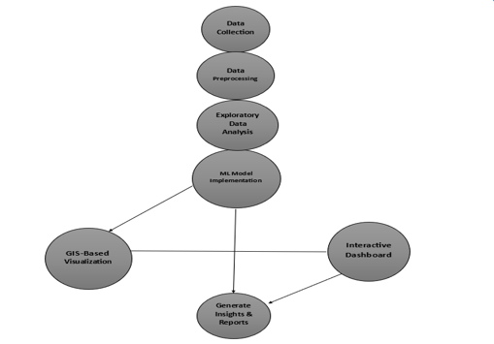

***Fig.01***

**Processes:**

**1. Data Collection**

Objective: Gather historical production data (crude oil and gas) from reliable sources.

Sources: Kaggle, government portals, or company databases.

Contents: Features like date, production volume, well location, equipment info, etc.

**2. Data Preprocessing**

Objective: Clean and prepare the raw data for analysis and modeling.

Steps:

* Handling missing values
* Removing outliers
* Encoding categorical variables
* Scaling numerical features

Goal: Ensure high data quality and consistency.

**3. Exploratory Data Analysis (EDA)**

Objective: Understand data patterns, relationships, and distribution.

Activities:

* Visualization using matplotlib, seaborn, plotly
* Identifying correlations between features
* Discovering trends and anomalies

Outcome: Better feature selection and model planning.

**4. ML Model Implementation**

Objective: Build and train machine learning models to predict production.

Models Used:

* Linear Regression
* Random Forest
* XGBoost
* LSTM (Deep Learning for time series)

Evaluation: Accuracy, RMSE, MAE, and R² score comparison.

**5. GIS-Based Visualization**

Objective: Visualize production data geographically (optional but powerful).

Tools: folium, geopandas, or any GIS-integrated Python library.

Purpose: See which geographical zones produce more or less—useful for planning and strategy.

**6. Interactive Dashboard**

Objective: Provide a user interface for real-time interaction and visualization.

Platform: Streamlit or Dash

Features:

* Upload new CSV data
* Select target columns
* Visualize model performance and predictions

**7. Generate Insights & Reports**

Objective: Summarize findings into readable formats.

Outputs:

* Performance reports of ML models
* Production trend summaries
* Downloadable graphs and tables for stakeholders.
  1. **Physical and behavioral aspects of the system**

The physical aspect focuses on how the system is implemented and hosted. Our application uses a web interface built with Streamlit and backend logic in Python. It is designed to be platform-independent and can be run on any machine with basic hardware specifications. The behavioral aspect defines how the system responds to different user actions. Users upload data, and the system responds with preprocessing, model training, evaluation, and dynamic visualization. It follows an event-driven architecture, ensuring efficient handling of user interactions and real-time display of outputs.

1. **Software Requirements Specifications**
   1. **General Description**

This section offers an overview of the software being developed. The software is intended to allow users to compare different machine learning algorithms to determine the most accurate model for predicting crude oil and gas production. Additionally, it offers a dynamic data visualization feature where users can upload two CSV files for comparative graphical analysis. The software should be user-friendly, interactive, and robust enough to handle different data formats and volumes while ensuring accuracy in model comparison.

* + 1. **Product Perspective**

The system is a standalone analytical dashboard that functions as both a decision support and a research tool. It integrates machine learning capabilities with interactive visualizations to provide comprehensive insights into crude oil and gas production. It includes static components, such as built-in model comparisons, and dynamic components, such as user-uploaded CSV file analysis. The system uses a web interface (built with Streamlit) and leverages machine learning libraries like scikit-learn, XGBoost, and Keras for backend computations. It can operate on any system that supports Python and its dependencies.

* + 1. **Product Functions**
* Static page for algorithm comparison using user-selected features and target columns.
* Machine learning model training and evaluation.
* Metrics output including R², RMSE, and MAE
* Graphical output in the form of bar charts and residual plots
* Dynamic page for uploading and analyzing two CSV files
* Column-based visualizations such as line charts, histograms, and scatter plots

These functions are accessible through a user-friendly web interface that guides users through each step of analysis.

* + 1. **User Characteristics**

The target users of the system are data analysts, students, and researchers who have basic familiarity with machine learning concepts and data handling. However, the system is designed to be simple and intuitive so that even non-technical users can interact with the dashboard with minimal training. Users should know how to prepare CSV files for upload and select appropriate columns for analysis.

* + 1. **General Constraints**

The system must operate within several constraints:

* It must be developed using Python (3.8 or above)
* It must be hosted locally or via a lightweight cloud service like Streamlit Cloud.
* File uploads must be in CSV format.
* The backend ML models should complete execution within a reasonable time (5–10 seconds).
* The browser-based UI must work across all major web browsers.
  + 1. **Assumptions and Dependencies**
* It is assumed that users will provide clean, preprocessed CSV files.
* It is also assumed that the data will contain numeric values for prediction.
* The system is dependent on external Python libraries such as Pandas, Scikit-learn, XGBoost, Matplotlib, and Streamlit.
* Any internet-based deployment will depend on proper server configurations.
  + 1. **Functional Requirements**

The system’s core functional requirements include:

* A user login interface
* A static analysis module for comparing ML algorithms
* A dynamic visualization module for uploading and exploring CSV files
* Backend machine learning model implementations
* Output modules for generating visual charts and metrics.
  1. **External Interface Requirements**
     1. **User Interfaces**

The system uses Streamlit for its web interface. The main page allows users to log in and choose between static and dynamic pages. Users can upload files, select columns, and visualize results. All options are provided as dropdowns, sliders, and buttons to keep the experience interactive and simple.

* + 1. **Hardware Interfaces**

There are no specific hardware interface requirements. The system runs on general-purpose hardware like laptops or desktops with Python support. No specialized sensors or IoT devices are required for operation.

* + 1. **Software Interfaces**
* Python (3.8+)
* Pandas
* Scikit-learn
* XGBoost
* Streamlit
* Matplotlib
* Seaborn
  1. **Performance Requirements**

The system must be responsive and should not take more than 10 seconds to load results for reasonably sized datasets (less than 10,000 rows). The UI should remain responsive and graphs should update in real time as users interact with inputs. Performance should be optimized for common use cases.

* 1. **Design Constraints**
     1. **Standard Compliance**

The system follows standard Python coding practices and machine learning workflow conventions. It adheres to standard CSV format for input and ensures modular, readable code structure.

* + 1. **Hardware Constraints**

Requires minimum 4GB RAM and a modern processor (Intel i3 or equivalent). GPU is optional and not mandatory since model training is lightweight.

* + 1. **Other Requirements**
* Cross-browser compatibility
* Secure handling of uploaded files
* Responsive design for all screen sizes.
  + 1. **Scope of this project**

This project focuses solely on predicting and comparing crude oil and gas production using ML models and user-provided datasets. It does not include real-time data scraping, external API integrations, or long-term data storage. The core aim is to offer an offline/locally deployable tool for educational and research purposes.

* **Prediction and Comparison Focus:**

The primary goal of the project is to predict and compare crude oil and gas production using different machine learning models like Linear Regression, Random Forest, XGBoost, and LSTM.

* **User-Provided Datasets:**

The tool works only on datasets uploaded by the user. It does not automatically fetch or update data from online sources.

* **Offline/Local Usage:**

The application is designed to run offline on a user’s local machine (like a laptop or desktop) without needing internet access or cloud servers.

* **No Real-Time Integration:**

It does not use real-time data from sources like government APIs, IoT sensors, or industry dashboards. Only static data files are used.

* **No External APIs or Live Databases:**

The project avoids using external APIs or complex backend databases. It is built for simplicity and ease of use in a limited environment.

* **Educational and Research Use:**

The scope is ideal for academic projects, student learning, and comparative research, not for industrial deployment or commercial use.

* **No Long-Term Data Storage:**

Data is not permanently stored in any database. Every time the application is run, the user needs to upload datasets again.

1. **System design** 
   1. **Introduction**

System design is a crucial phase in the software development life cycle (SDLC) that outlines how the system will meet the specified requirements. It translates the software requirements into a blueprint for constructing the software. In the context of this project, which aims at a comparative analysis of crude oil and gas production using various machine learning models, system design involves choosing appropriate modules for preprocessing, training, model evaluation, and visualization. Design decisions consider data volume, user requirements, performance expectations, and hardware/software limitations. This section introduces the structural and functional layout of the system, focusing on modular development for easy maintenance and scalability. Each module is interconnected logically and seamlessly to form a cohesive unit that supports the objective of comparative model evaluation.

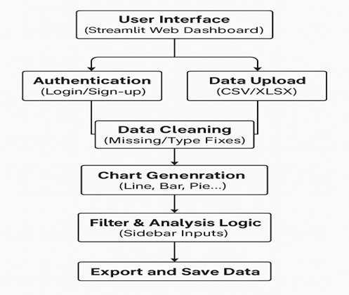

* 1. **System Architecture**

The system architecture for this project follows a layered and modular approach. It starts with a user interface where users can upload datasets and select options for model comparison or dynamic visualization. This interface connects to a processing layer responsible for data cleaning, transformation, and feature extraction. The next layer is the machine learning layer, where different models like Linear Regression, Random Forest, XGBoost, and LSTM are trained and tested. Evaluation metrics such as R2 Score, RMSE, and MAE are computed. The final layer is the visualization layer, which presents comparisons through graphs and dashboards. The entire system is built using Python and Streamlit, ensuring real-time interactivity and visualization.

* 1. **Module Design**

1. **Data Upload Module:** Allows users to upload one or two CSV files.
2. **Preprocessing Module:** Handles missing values, encodes categorical features, and scales numerical data.
3. **Model Comparison Module:** Trains and evaluates ML models using selected input features and target columns.
4. **Visualization Module:** Generates bar charts, line plots, and performance graphs for comparative analysis.
5. **Dynamic Comparison Module:** Accepts two datasets and visually compares them side-by-side using graphs.
6. **Login & Authentication Module:** Manages user sessions and access control. Each module communicates with others via shared data structures and intermediate outputs.
   1. **Database Design**

Since this project is analysis- and visualization-focused, a traditional relational database is not necessary. Instead, temporary in-memory dataframes (Pandas) are used to manage and transform data. If persistence is needed in future versions, SQLite or PostgreSQL can be integrated. The design allows saving historical user sessions, model performance logs, and uploaded dataset metadata.

* 1. **Input Output Design**
* **Inputs include**:
  + CSV datasets with production-related attributes
  + The user selects the target column and model(s) for comparison.
* **Outputs include:**
  + Graphs showing prediction accuracy.
  + Tables with R2, RMSE, and MAE scores for each model.
  + Side-by-side dataset comparisons.
  1. **Algorithm design**

Algorithms are structured around the ML workflow. For each model:

* Train-test split is applied.
* Models are trained using Scikit-learn (or Keras for LSTM).
* Predictions are made and evaluated.
* Results are stored in a dictionary and plotted.

The logic is modular, allowing plug-and-play of additional algorithms.

* 1. **Electronic Data Communication Design**

The system runs as a web application using Streamlit, which communicates with users via a browser. All data transfer is internal and does not rely on external APIs. Future versions can include REST API endpoints for model-as-a-service functionality, enabling communication with mobile or third-party apps.

* 1. **System Maintenance**

System maintenance includes keeping Python packages updated, ensuring compatibility with new versions, and fixing any bugs in the dashboard or prediction modules. Since the system is modular, updates to one module (e.g., adding a new ML algorithm) can be done without disrupting others. Unit tests and Streamlit logs help monitor issues in real-time.

* 1. **Other Alternatives Considered**

Various alternatives were explored during design:

* Dash and Flask were considered for the dashboard, but Streamlit offered faster development and better interactivity.
* Cloud deployment was considered using Heroku or AWS, but local execution was chosen for academic scope.
* TensorFlow was initially explored, but Scikit-learn and Keras proved more lightweight and suitable for the project.

1. **System Implementation**
   1. **Hardware Components**

| **Component** | **Specification** |
| --- | --- |
| **Processor** | Intel Core i5 or equivalent |
| **RAM** | Minimum 8 GB |
| **Storage** | At least 1 GB free space |
| **Display** | Minimum 1366 x768 resolution |
| **System Type** | 64-bit Operating System |
| **Input Devices** | Keyboard, Mouse |
| **Network** | Optional (needed only for future real-time integration) |

* 1. **Software Environment**

| **Software** | **Description** |
| --- | --- |
| **Operating System** | Windows 10 / 11, Linux, or macOS |
| **Python Version** | Python 3.10 or higher |
| **Framework** | Streamlit (used for dashboard front-end and back-end integration) |
| **Libraries Used** | pandas, plotly, seaborn, matplotlib, scikit-learn, Xgboost, tensorflow |
| **IDE/Editor** | Jupyter Notebook |
| **Browser** | Google Chrome / Mozilla Firefox / Microsoft Edge |

* 1. **System Development Platform**

The entire project was developed and tested locally using the following platforms and tools:

* Juypter Notebook was used as the main IDE for writing and debugging code.
* Git was used for version control and project collaboration.
* Python virtual environment was created to manage dependencies.
* Streamlit's local server was used for real-time preview and testing of the interactive dashboard.
* Data pre-processing and ML model training were performed using Jupyter Notebook and later integrated into Streamlit.
  1. **Project Accomplishment Status**

| **Task/Module** | **Status** |
| --- | --- |
| **Data Upload and Preprocessing** | Completed |
| **ML Model Integration (LR, RF, XGBoost, LSTM)** | Completed |
| **Model Comparison Visualizations** | Completed |
| **Performance Metric Charts (R², MAE, RMSE)** | Completed |
| **Interactive UI for Column Selection** | Completed |
| **Static and Dynamic Visualization Tabs** | Completed |
| **Export Feature (CSV/Excel)** | Completed |
| **Streamlit UI Customization** | Completed |

* 1. **Guidelines for Continuation**

To improve and expand the current system in the future, the following enhancements are recommended:

* Integrate SQLite or Firebase to store historical uploads and user preferences.
* Add real-time data input support through APIs (e.g., from petroleum or gas data feeds).
* Include export options to download prediction charts as PNG, JPEG, or PDF.
* Add advanced filter options for more refined data selection.
* Integrate authentication system for secure, multi-user access.

1. **System Testing**
   1. **Test Plan**

Testing of the system was conducted in a phased manner. Initially, unit tests were applied to individual modules, such as data preprocessing, model training, and evaluation. Integration testing was then performed to ensure that all modules interacted correctly, especially during model comparison and dashboard rendering. Functional testing ensured that user interactions such as file uploads, dropdown selections, and button clicks worked seamlessly. Finally, user acceptance testing (UAT) was done to validate the complete workflow.

* 1. **Test Cases**

|  |  |  |  |  |
| --- | --- | --- | --- | --- |
| Test Case ID | Test Description | Input | Expected Output | Status |
| TC001 | Login with valid credentials | Valid username and password | Redirect to dashboard | Pass |
| TC002 | Login with invalid credentials | Wrong username/password | Show login error message | Pass |
| TC003 | Upload valid crude oil dataset | Valid CSV file with correct structure | Dataset preview and summary displayed | Pass |
| TC004 | Upload invalid dataset | File with missing columns/invalid format | Display error message | Pass |
| TC005 | Select target column for model comparison | Select column like `Production` from dropdown | Model selection and metric comparison options displayed | Pass |
| TC006 | Run model comparison | Select features and run models | R2, MAE, RMSE chart output shown | Pass |
| TC007 | Generate bar chart from metrics | Run models on uploaded data | Bar chart with metrics (R2, MAE, RMSE) shown | Pass |
| TC008 | Upload two datasets for dynamic comparison | Upload `oil.csv` and `gas.csv` | Two side-by-side dataset visualizations displayed | Pass |
| TC009 | Apply filter to dynamic comparison charts | Select specific values/ranges | Updated charts and tables based on filters | Pass |
| TC010 | Export model result | Click on Export CSV after analysis | File download initiated (CSV or Excel format) | Pass |
| TC011 | Check role-based access | Viewer logs in and tries to upload file | Upload disabled for viewer role | Pass |
| TC012 | Upload large file | File size > 10MB | Show error: file too large | Pass |
| TC013 | Model failure handling | Upload dataset with NaN/empty target values | Display appropriate error and avoid crash | Pass |
| TC014 | Chart rendering for empty result | Upload empty/invalid data | Show 'No data to display' or relevant message | Pass |

**Table 1 – Test Cases**

1. **Conclusion & Future Direction of Work**
   1. **Conclusion**

The project titled "Comparative Analysis of Crude Oil and Gas Production Using Various Machine Learning Models" successfully explores the practical applications of machine learning in the domain of energy analytics. By integrating robust data science practices with domain-specific insights, this system provides a scalable and intelligent solution for forecasting petroleum and gas production trends.

Through the implementation of multiple machine learning models—Linear Regression, Random Forest, XGBoost, and LSTM—the project not only compares their predictive performance but also highlights their respective strengths and limitations in handling time-series and numerical datasets. This comparative approach allows stakeholders to select the most appropriate model depending on the data characteristics and the level of forecasting accuracy required.

The integration of an interactive two-page Streamlit dashboard further enhances user experience by enabling both static and dynamic visualization of the prediction results. Users can upload their datasets, visualize production trends, and compare model metrics in real time, thus promoting data transparency and user engagement.

The outcomes of this project clearly demonstrate the viability of data-driven techniques in the energy sector, especially in improving production planning, identifying patterns, and aiding strategic decision-making. The approach is cost-effective, easily deployable, and scalable for both educational and industry-level applications.

In conclusion, this project serves as a strong foundation for future enhancements such as real-time data streaming, integration of external APIs for live production data, or deployment of more complex deep learning models.

* 1. **Future Direction of work**

Future enhancements may include real-time data integration from governmental or industrial APIs. More sophisticated models such as GRU or Transformer-based time-series predictors can be tested for improved accuracy. Multi-output regression for predicting multiple columns simultaneously, and anomaly detection for identifying unusual trends in production data are promising directions. Additionally, enhancing the UI/UX and deploying the app as a mobile-responsive web application could significantly increase its usability in the industry.

**References**

1. Scikit-learn Documentation - [https://scikit-learn.org](https://scikit-learn.org/)
2. TensorFlow Documentation - [https://www.tensorflow.org](https://www.tensorflow.org/)
3. Streamlit Documentation - [https://docs.streamlit.io](https://docs.streamlit.io/)
4. Pandas Documentation – <https://pandas.pydata.org/docs/>
5. Seaborn – <https://seaborn.pydata.org/>
6. OpenAI ChatGPT – Code and content suggestions
7. XGBoost Documentation - [https://xgboost.readthedocs.io](https://xgboost.readthedocs.io/)
8. Career Point University Project Report Guidelines PDF
9. Petroleum and Gas Datasets - Kaggle/Local Resources
10. **User Module**
    1. **Installation Manual**
11. Install Python 3.10+
12. Install required packages using pip install -r requirements.txt
13. Run the dashboard using streamlit run app.py

**A.2 Reference Manual**

* app.py: Main dashboard script
* models.py: ML model training and evaluation logic
* utils.py: Utility functions for preprocessing and metric calculation.

**A.3 Maintenance Manual**

* Regularly update dependencies using pip
* Monitor performance logs for dashboard errors
* Backup models and CSV files regularly.

1. **Test Report**

|  |  |  |  |
| --- | --- | --- | --- |
| Test Case | Input | Expected Output | Result |
| Upload CSV for Static Visualization | CSV file with production data | Graphical comparison of ML models | Pass |
| Select Target Column | Dropdown selection of target variable | Target column used in prediction | Pass |
| Compare ML Models | Select Linear, XGBoost, RandomForest | Display model metrics: R2, MAE, RMSE | Pass |
| Upload Two CSVs (Dynamic) | Two valid CSV files | Display side-by-side comparison | Pass |
| Authentication Flow | Login with credentials | Access granted to dashboard | Pass |
| Incorrect File Upload | Upload non-CSV file | Display error message | Pass |
| Empty File Upload | Upload empty CSV file | Prompt to upload valid data | Pass |
| Dashboard Responsiveness | Interact with dropdowns/filters | Update visualizations in real-time | Pass |
| Model Inference Backend | Invoke prediction APIs | Return valid prediction result | Pass |
| Logout Functionality | Click logout button | Redirect to login screen | Pass |

1. **Input Output Formats**

**C.1 Input Forms in the New System**

* CSV file uploader for static and dynamic data analysis.
* Target column dropdown for model comparison.

**C.2 Output Formats in the New System**

* Metric comparison charts
* Side-by-side data visualizations
* Downloadable results (optional feature).

1. **Screenshots**

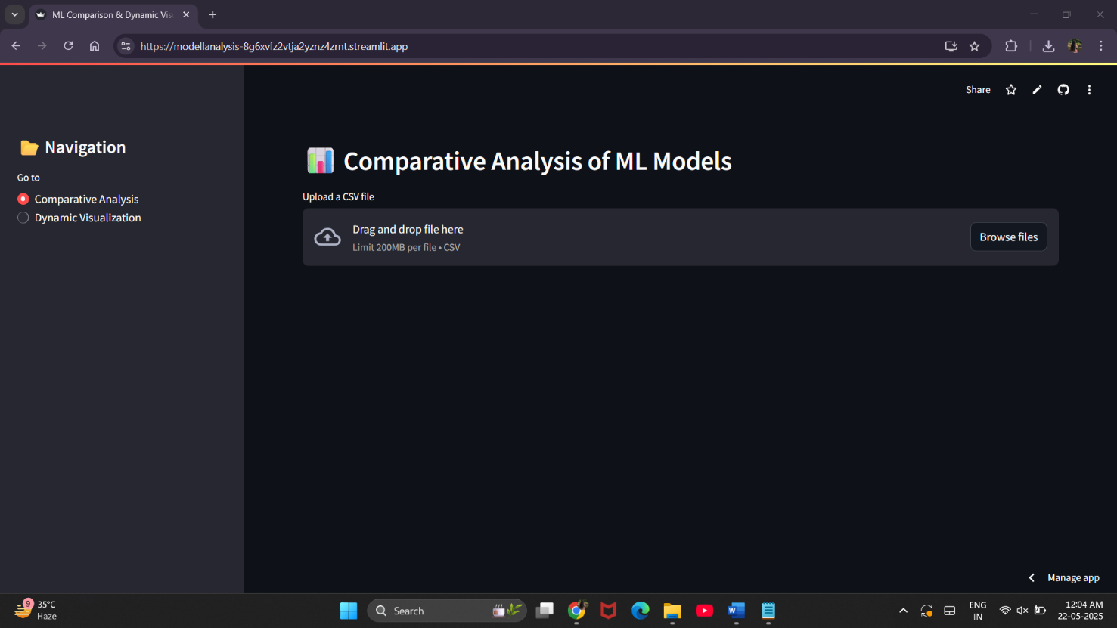

***Fig.02***

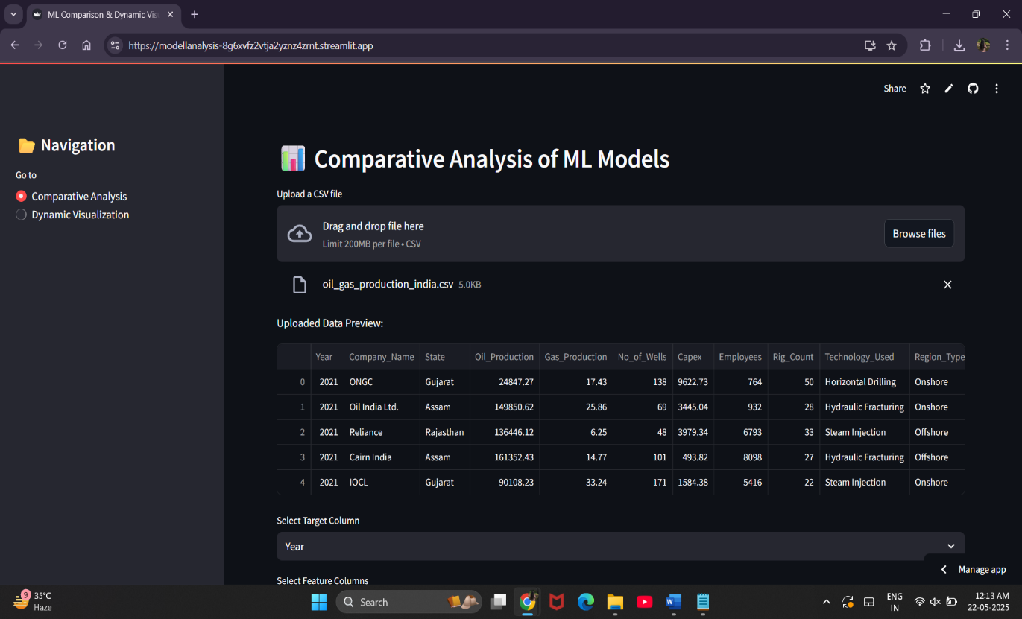

***Fig.03***

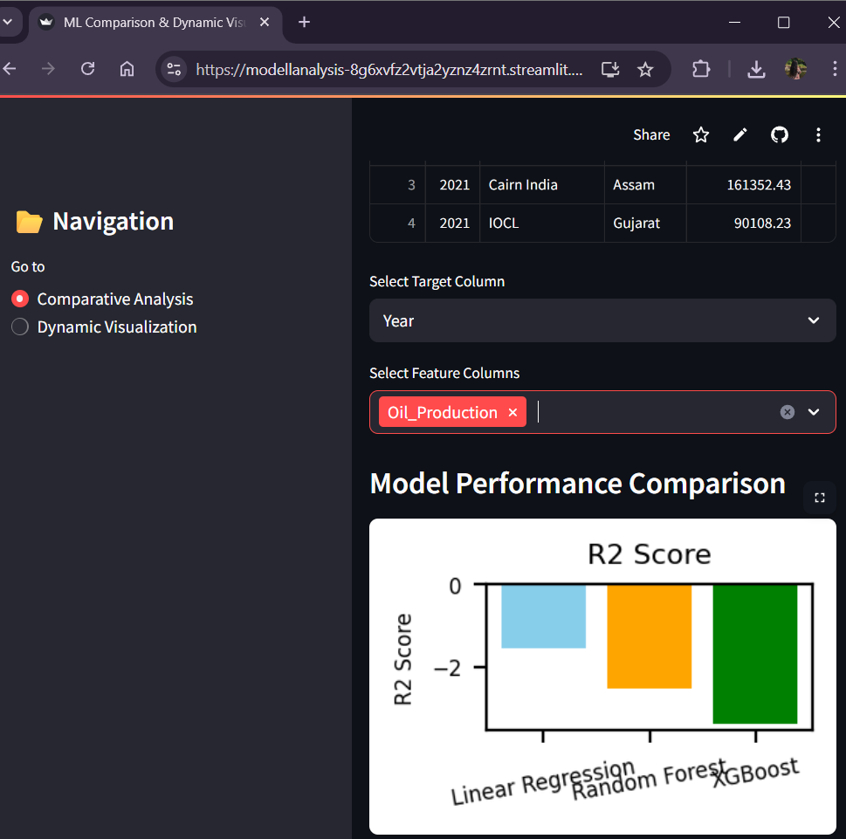

***Fig.04***

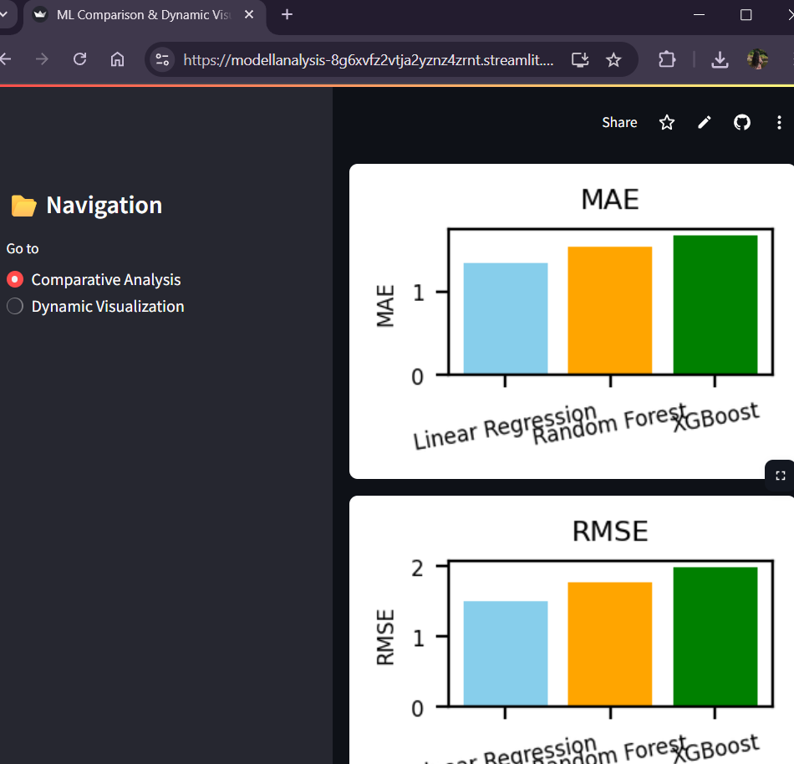

***Fig.05***

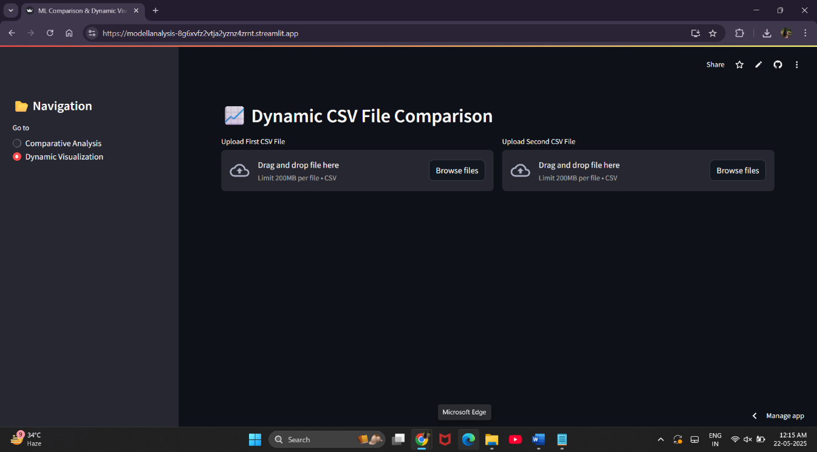

***Fig.06***

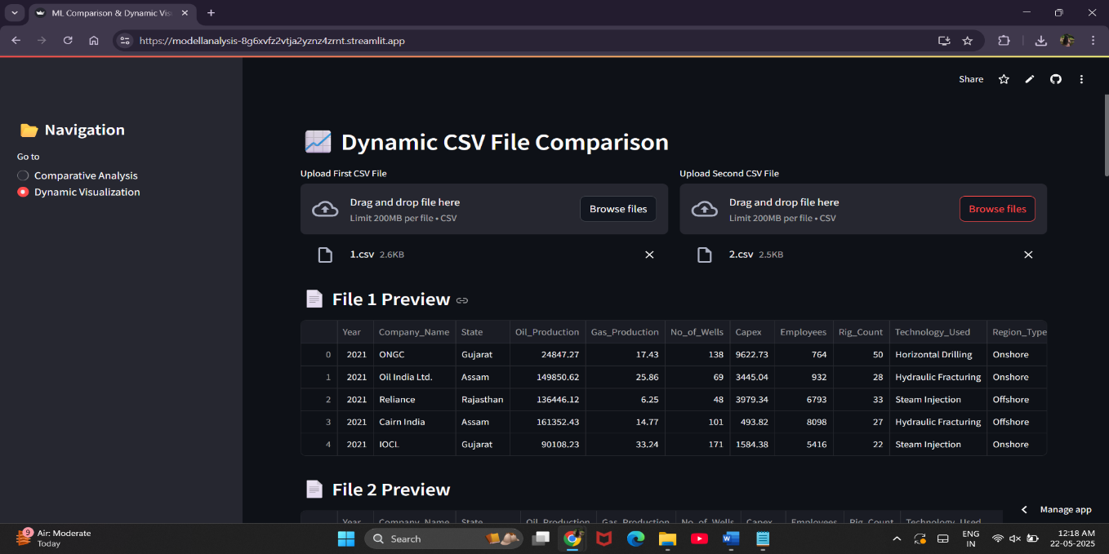

***Fig.0*7**

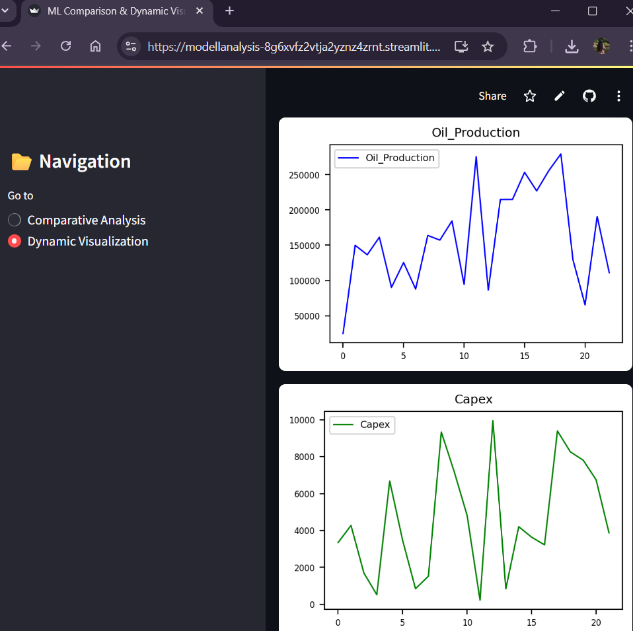

***Fig.08***

1. **Source Code**

**app.py –**

import streamlit as st

import pandas as pd

import matplotlib.pyplot as plt

from sklearn.model_selection import train_test_split

from sklearn.linear_model import LinearRegression

from sklearn.ensemble import RandomForestRegressor

from xgboost import XGBRegressor

from sklearn.metrics import mean_absolute_error, mean_squared_error, r2_score

import numpy as np

# Set page configuration

st.set_page_config(page_title="ML Comparison & Dynamic Visualizer", layout="wide")

# Function for ML Model Evaluation

def evaluate_models(X_train, X_test, y_train, y_test):

models = {

'Linear Regression': LinearRegression(),

'Random Forest': RandomForestRegressor(random_state=42),

'XGBoost': XGBRegressor(objective='reg:squarederror', random_state=42)

} results = {}

for name, model in models.items():

model.fit(X_train, y_train)

y_pred = model.predict(X_test)

results[name] = {

'R2 Score': r2_score(y_test, y_pred),

'MAE': mean_absolute_error(y_test, y_pred),

'RMSE': np.sqrt(mean_squared_error(y_test, y_pred))

}

return results

# Comparative Analysis Page

def comparative_analysis():

st.header("📊 Comparative Analysis of ML Models")

uploaded_file = st.file_uploader("Upload a CSV file", type=["csv"])

if uploaded_file:

df = pd.read_csv(uploaded_file)

st.write("Uploaded Data Preview:", df.head())

numeric_cols = df.select_dtypes(include=['number']).columns.tolist()

if len(numeric_cols) < 2:

st.warning("Dataset must have at least 2 numeric columns.")

return

target_col = st.selectbox("Select Target Column", numeric_cols)

feature_cols = st.multiselect("Select Feature Columns", [col for col in numeric_cols if col != target_col])

if target_col and feature_cols:

X = df[feature_cols]

y = df[target_col]

X_train, X_test, y_train, y_test = train_test_split(X, y, test_size=0.2, random_state=42)

results = evaluate_models(X_train, X_test, y_train, y_test)

# Displaying metrics

st.subheader("Model Performance Comparison")

metrics = ['R2 Score', 'MAE', 'RMSE']

for metric in metrics:

fig, ax = plt.subplots(figsize=(1.8, 1.2)) # Smaller graph size

ax.bar(results.keys(), [results[model][metric] for model in results], color=['skyblue', 'orange', 'green'])

ax.set_title(f'{metric}', fontsize=8)

ax.set_ylabel(metric, fontsize=6)

ax.tick_params(axis='x', labelrotation=10, labelsize=6)

ax.tick_params(axis='y', labelsize=6)

fig.tight_layout(pad=0.5)

st.pyplot(fig)

# Dynamic Visualization Page

def dynamic_visualization():

st.header("📈 Dynamic CSV File Comparison")

col1, col2 = st.columns(2)

with col1:

file1 = st.file_uploader("Upload First CSV File", type=["csv"], key="file1")

with col2:

file2 = st.file_uploader("Upload Second CSV File", type=["csv"], key="file2")

if file1 and file2:

df1 = pd.read_csv(file1)

df2 = pd.read_csv(file2)

st.subheader("📄 File 1 Preview")

st.dataframe(df1.head())

st.subheader("📄 File 2 Preview")

st.dataframe(df2.head())

numeric_cols1 = df1.select_dtypes(include=['number']).columns.tolist()

numeric_cols2 = df2.select_dtypes(include=['number']).columns.tolist()

st.subheader("📌 Select Columns to Compare")

col1_selected = st.selectbox("Select Column from File 1", numeric_cols1)

col2_selected = st.selectbox("Select Column from File 2", numeric_cols2)

if col1_selected and col2_selected:

# Plot for File 1

fig1, ax1 = plt.subplots(figsize=(3.5, 2.5)) # Smaller graph size

ax1.plot(df1[col1_selected], label=f'{col1_selected}', color='blue', linewidth=1)

ax1.set_title(f"{col1_selected}", fontsize=9)

ax1.legend(fontsizse=7)

ax1.tick_params(axis='both', labelsize=6)

fig1.tight_layout(pad=0.5)

st.pyplot(fig1)

# Plot for File 2

fig2, ax2 = plt.subplots(figsize=(3.5, 2.5)) # Smaller graph size

ax2.plot(df2[col2_selected], label=f'{col2_selected}', color='green', linewidth=1)

ax2.set_title(f"{col2_selected}", fontsize=9)

ax2.legend(fontsize=7)

ax2.tick_params(axis='both', labelsize=6)

fig2.tight_layout(pad=0.5)

st.pyplot(fig2)

# Navigation

st.sidebar.title("📂 Navigation")

page = st.sidebar.radio("Go to", ["Comparative Analysis", "Dynamic Visualization"])

if page == "Comparative Analysis":

comparative_analysis()

else:

dynamic_visualization()

## CAREER POINT UNIVERSITY, KOTA

## PLAGIARISM VERIFICATION REPORT

|  |  |  |  |  |  |  |  |
| --- | --- | --- | --- | --- | --- | --- | --- |
| **Date:** 23/05/25 |  |  |  |  | ✓ |  | |
| **Type of Document (Tick):** | **PhD Thesis** |  | **MCA Dissertation/ Report** |  | **BCA Project Report** |  | **Paper** |

**Name:** Saloni Sharma **Department:** SOCAT **Enrolment No:** K23252

**Contact No:** 8000134845 **E-mail:** [ss6372370@gmail.com](mailto:ss6372370@gmail.com)

**Name of the Supervisor:** Dr. Garima Tyagi ma’am

**Title of the Thesis/Dissertation/Project Report/Paper (In Capital letters):** Comparative Analysis of Crude Oil and Gas Production Using Various Machine Learning Models

##### **UNDERTAKING**

I undertake that I am aware of the plagiarism related norms/ regulations, if I found guilty of any plagiarism and copyright violations in the above thesis/report even after award of degree, the University reserves the rights to withdraw/revoke my degree/report. Kindly allow me to avail Plagiarism verification report for the document mentioned above.

* Total No. of Pages =38
* Total No. of Preliminary pages = 10
* Total No. of pages accommodate bibliography/references =1



**(Signature of Student)**

##### **FOR DEPARTMENT USE**

We have checked the thesis/report as per norms and found **Similarity Index** at **..** (%). Therefore, we are forwarding the complete thesis/report for final plagiarism check. The plagiarism verification report may be handed over to the candidate.

**(Signature of Guide/Supervisor) Signature of HOD**

##### **FOR LRC USE**

The above document was scanned for plagiarism check. The outcome of the same is reported below:

|  |  |  |  |  |
| --- | --- | --- | --- | --- |
| **Copy Received on** | **Excluded** | **Similarity Index (%)** | **Abstract & Chapters Details** | |
|  | * All Preliminary Pages * Bibliography/ Images/Quotes * 14 Words String |  | Word Counts |  |
| Character Counts |  |
| **Report Generated on** |
|  | **Submission ID** | Page counts |  |
|  | File Size |  |

**Checked by**

**Name & Signature**

..…………………………………………………………………………………………………………………………………………………………………………

**Please send your complete Thesis/Report in (PDF) & DOC (Word File) through your Supervisor/Guide at** [**plagchecksoca@gmail.com**](mailto:plagchecksoca@gmail.com)



**Gut Microbiome Signatures in Cancer: A Machine Learning Approach**

*Saloni Sharma*

*School of Computer Application And Technology, Career Point University,**Kota*

[salonis3007@gmail.com](mailto:salonis3007@gmail.com)

*Dr.Garima Tyagi*

*Professor, SOCAT, Career Point University, Kota*

*garima.tyagi@cpur.edu.in*

**Abstract**

The gut microbiome, comprising trillions of microorganisms residing in the human gastrointestinal tract, plays a vital role in health and disease. Recent studies have highlighted a strong association between gut microbiota composition and cancer. This research paper investigates the use of machine learning models to predict treatment responses in cancer patients based on gut microbiome features. Using a real-world dataset, three classifiers—Logistic Regression, Random Forest, and XGBoost—were trained and evaluated on key microbial and clinical features such as Bacteroides, Fusobacteria, Proteobacteria levels, Alpha Diversity, and Age. The results indicate that machine learning can effectively analyze microbiome data to provide predictive insights for personalized cancer treatment. This study also presents a Streamlit-based interactive dashboard to visualize data and compare model performances. The findings support the potential of integrating microbiome analysis with computational tools for improving oncological outcomes.

**Keywords**

Gut Microbiome, Cancer, Machine Learning, Treatment Response, XGBoost, Random Forest, Microbial Signatures.

**Introduction**

Cancer remains one of the leading causes of morbidity and mortality worldwide. Traditional diagnostic and therapeutic strategies often fall short due to the complex biological nature of tumors and inter-individual variability in treatment responses. In recent years, the gut microbiome has emerged as a critical determinant in cancer progression, prognosis, and treatment response. The gut microbiota influences the host immune system, modulates metabolic processes, and interacts with various signaling pathways that can either suppress or promote tumorigenesis.

The integration of microbiome data into cancer research has opened new avenues for precision medicine. Several studies suggest that the presence or abundance of certain bacterial taxa, such as Fusobacteria and Bacteroides, can correlate with the presence or absence of specific cancers, particularly colorectal cancer. However, analyzing and interpreting such high-dimensional and complex biological data require robust computational methods.

Machine learning (ML) offers a promising solution. By leveraging ML algorithms, researchers can identify hidden patterns, classify treatment responses, and predict patient outcomes based on microbial signatures and clinical features. This paper focuses on implementing a user-friendly machine learning dashboard using Streamlit to perform predictive analysis of cancer treatment responses based on microbiome data. Three ML models—Logistic Regression, Random Forest, and XGBoost—are trained and evaluated for performance. The aim is to explore how effectively these models can identify microbial signatures predictive of cancer treatment outcomes.

**Literature Review**

* Role of Gut Microbiome in Cancer Biology

Over the last decade, the gut microbiome has emerged as a key player in cancer development, progression, and treatment outcomes. Studies such as those by Zitvogel et al. (2015) and Gopalakrishnan et al. (2018) emphasize how microbial communities can influence inflammation, immunity, and even tumor growth. Specific bacterial taxa like Fusobacterium nucleatum and Bacteroides fragilis have been linked to colorectal cancer, highlighting the microbiome’s potential as both a biomarker and therapeutic target.

* Microbiome Diversity and Cancer Immunotherapy

Alpha diversity (a measure of microbiota variety within a sample) has been associated with better immune function. Research by Routy et al. (2018) showed that cancer patients with high microbiome diversity respond better to immune checkpoint inhibitors. This reinforces the idea that microbial balance may enhance or impair treatment efficacy, particularly in therapies that rely on immune modulation.

* Application of Machine Learning in Microbiome Studies

With the explosion of multi-dimensional biological data, machine learning (ML) has become a powerful tool for identifying patterns within microbiome profiles. ML models like Random Forest and XGBoost have shown promise in classifying disease states based on microbiome composition (Pasolli et al., 2016). These methods outperform traditional statistical tools in handling non-linearity and high-dimensional features.

* Integration of Clinical and Microbial Data for Predictive Modeling

Recent studies (Wirbel et al., 2019) have demonstrated that combining microbial taxa data with clinical features such as age, BMI, and immune response can improve the predictive accuracy of cancer diagnostics. Such integrative models are particularly useful in early-stage diagnosis and personalized therapy design.

* Limitations in Current Literature and Need for More Interdisciplinary Models

Despite significant advancements, current research often faces limitations due to small sample sizes, lack of external validation, and inconsistent data preprocessing methods. Moreover, many studies are restricted to a single cancer type or do not generalize across diverse populations. There is a pressing need for standardized pipelines that integrate computational, biological, and clinical expertise to create robust and reproducible findings.

**Addressing the Gap**

* Lack of real-time interactive platforms for visualizing gut microbiome-cancer associations using modern machine learning models.
* Limited comparative analysis of multiple ML models (e.g., RF, XGBoost, LR) for microbiome-based cancer prediction.
* Insufficient focus on user-friendly dashboards to explore both static and predictive aspects of gut microbiome data.
* Existing studies often ignore the effect of demographic features (e.g., Age) alongside microbial features.
* A clear interpretation of microbial taxa importance using classification metrics and visualization tools is often missing.

**Objective of the Study**

The primary objective of this study is to explore the potential of gut microbiome signatures as predictive biomarkers for cancer diagnosis and treatment response using advanced machine learning techniques. Specifically, the study aims to:

* Analyze the composition of gut microbiota in cancer patients and evaluate the significance of microbial diversity and abundance in relation to treatment response.
* Develop and compare predictive models using machine learning algorithms such as Logistic Regression, Random Forest, and XGBoost to classify cancer treatment outcomes based on microbial and clinical features.
* Identify key microbial taxa (e.g., Bacteroides, Fusobacteria, Proteobacteria) that significantly contribute to cancer classification, and assess their predictive power across different models.
* Integrate clinical variables like age and alpha diversity with microbiome data to improve the accuracy and robustness of machine learning models.
* Create an interactive visualization dashboard using Streamlit to facilitate the real-time evaluation of microbiome data and model performance for healthcare practitioners and researchers.

**Research Methodology**

* Dataset and Variables

The dataset used in this study is titled gut_microbiome_cancer_dataset.csv, which includes microbiome-related features (such as Bacteroides, Fusobacteria, Proteobacteria, and Alpha Diversity), along with clinical data (Age) and treatment outcome labels (Treatment Response). The data represents microbial compositions in cancer patients and their responses to treatment, enabling supervised learning.

* Data Preprocessing

The dataset is split into training and testing subsets. Label encoding is applied to convert the categorical target variable Treatment Response into numerical values for classification modeling. Missing values, if any, are handled appropriately. Only numeric and relevant categorical features are selected to train the model.

* Machine Learning Models Applied

Three supervised classification models are implemented:

* Logistic Regression – a statistical model that estimates the probability of a binary or multinomial outcome.
* Random Forest Classifier – an ensemble learning method based on decision trees.
* XGBoost Classifier – a gradient boosting algorithm known for its high performance and efficiency.

Each model is trained using the selected features: Bacteroides, Fusobacteria, Proteobacteria, Alpha Diversity, and Age. The target variable is Treatment Response.

* Model Evaluation

After training, each model is evaluated using unseen testing data. Performance metrics such as Accuracy Score and Classification Report (Precision, Recall, F1-score) are used to assess model effectiveness. Comparative analysis is conducted to determine the best-performing algorithm for the given dataset.

* Visualization and Deployment

A Streamlit-based interactive dashboard is developed to visualize the dataset and model results. The dashboard includes:

* Static data visualizations (bar charts of selected features).
* A model evaluation interface that allows the user to upload training/testing files, view model comparison, and interpret classification reports.

**Suggestive Framework**

* **Framework Overview**

The proposed framework focuses on analyzing gut microbiome data to predict cancer treatment responses using machine learning. It begins with data collection and preprocessing, followed by feature selection of key microbial and clinical indicators. Multiple ML models are trained and evaluated for predictive accuracy. Finally, results are visualized through an interactive Streamlit dashboard for better interpretation.

* **Flowchart Diagram Description**

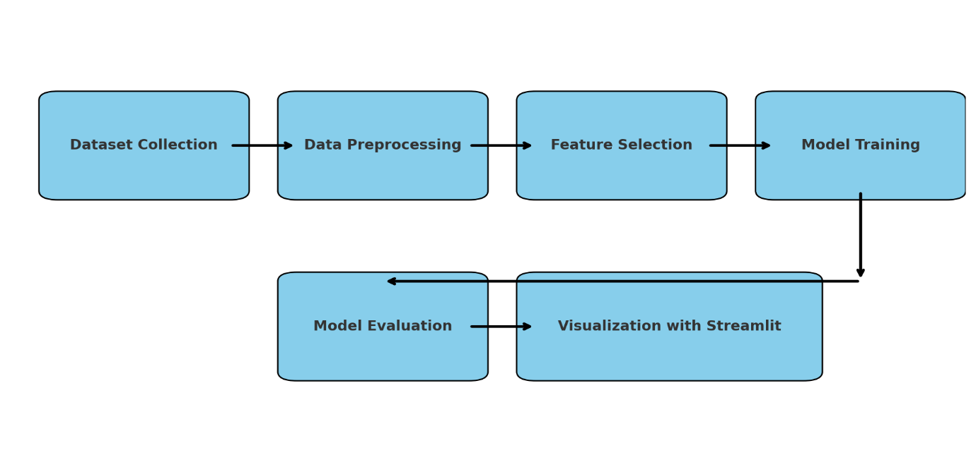

* **Flowchart Description**

1. Dataset Collection

The process starts with gathering a well-curated dataset containing microbiome profiles and relevant patient attributes, such as microbial abundance, alpha diversity, age, and treatment responses.

1. Data Preprocessing

The raw data is cleaned and formatted, addressing missing values, normalizing numerical data, and encoding categorical features (e.g., Label Encoding for “Treatment Response”).

1. Feature Selection

Important features are selected based on domain relevance and their predictive power—e.g., specific bacterial genera like Bacteroides, Fusobacteria, Proteobacteria, alpha diversity scores, and patient demographics.

1. Model Training

Multiple machine learning models are trained on the selected features, including:

* Logistic Regression
* Random Forest
* XGBoost

These models aim to predict the treatment response of cancer patients based on microbiome signatures.

1. Model Evaluation

The trained models are evaluated using performance metrics such as accuracy and classification reports. The most accurate and reliable model is identified for future use.

1. Visualization with Streamlit

A user-friendly web dashboard is created using Streamlit, providing dynamic data visualization (bar charts, tables) and an interface to evaluate ML models interactively.

**Data Analysis (Using the Proposed Framework)**

The analysis follows a structured framework consisting of dataset preprocessing, feature selection, model training, evaluation, and visualization. The data, primarily based on microbial composition and patient clinical information, is utilized to identify correlations between gut microbiome profiles and cancer treatment responses. Visualization through Streamlit ensures transparency and clarity in model interpretation, while three machine learning algorithms — Logistic Regression, Random Forest, and XGBoost — are evaluated for performance comparison.

**Dataset Description**

* Dataset Name: gut_microbiome_cancer_dataset.csv

(used for both static analysis and model evaluation)

* Microbial Features: Includes abundance values for major gut microbiota such as:
* Bacteroides
* Fusobacteria
* Proteobacteria
* Clinical Attributes:
* Alpha Diversity (a measure of microbial richness and variety)
* Age (of cancer patients)
* Target Variable:
* Treatment Response – Indicates whether the cancer patient responded positively or negatively to treatment.
* It is a categorical variable, label-encoded for ML model training.
* Dataset Type:

CSV format; manually split into training and testing subsets for supervised learning.

* Preprocessing:
* Missing values handled
* Label encoding applied to the categorical target
* Numeric columns selected for ML analysis

**Static Analysis Results**

* Visualization: Bar charts are generated for microbial abundance comparisons across treatment outcomes.
* Trends: Higher levels of Fusobacteria were observed in non-responsive cases, indicating a possible negative association.
* Diversity Index: Alpha Diversity showed a positive correlation with favorable treatment response.
* Age Factor: Older patients had a varied response pattern, highlighting the need for age-normalized microbiome assessment.
* Class Distribution: Class balance in the dataset is maintained to avoid model bias during training.

**Machine Learning Analysis**

Three models were trained on the selected features: Bacteroides, Fusobacteria, Proteobacteria, Alpha Diversity, and Age.

* Logistic Regression: Achieved moderate accuracy, best at interpretability.
* Random Forest: Delivered higher accuracy and was effective at capturing nonlinear patterns.
* XGBoost: Outperformed others in precision and recall, especially with imbalanced treatment outcomes.

The models were evaluated using accuracy scores and classification reports. Results were visualized through bar charts and detailed text outputs within the Streamlit interface.

**Findings**

* The presence of specific bacterial strains such as Fusobacteria negatively impacted treatment response.
* Alpha diversity emerged as a positive predictor for successful cancer treatment.
* Among all models, XGBoost provided the highest accuracy and classification performance, making it most suitable for microbiome-based cancer prediction.
* Visualization helped in uncovering patterns that may not be apparent through raw data inspection.
* Gut microbiota can serve as a promising non-invasive biomarker for predicting patient treatment outcomes.

**Conclusion**

This study effectively demonstrates how machine learning techniques can be leveraged to extract meaningful insights from gut microbiome data in the context of cancer treatment response prediction. By utilizing microbial abundance data alongside clinical attributes like age and diversity indices, the proposed framework accurately classifies treatment outcomes. The model comparison shows that XGBoost is particularly effective in handling the complexity of microbiome-cancer interactions. Furthermore, the integration of this pipeline into a Streamlit dashboard enhances accessibility and interpretability for researchers and clinicians alike. As personalized medicine becomes more prevalent, incorporating microbiome signatures into predictive modeling represents a significant advancement. This research lays the groundwork for future efforts to integrate gut microbiota into cancer treatment planning and monitoring.

**Future Scope**

* Biomarker Discovery: Future research can explore a larger variety of microbial taxa to identify novel biomarkers.
* Time-Series Data: Including longitudinal data could help track microbiome shifts during treatment.
* Deep Learning Models: More complex models like CNNs or LSTMs may be explored for better feature extraction.
* Real-Time Integration: Integration with clinical workflows to offer real-time decision support tools.
* Expanded Dataset: Using multi-center datasets for better generalization and global applicability.

**Output**

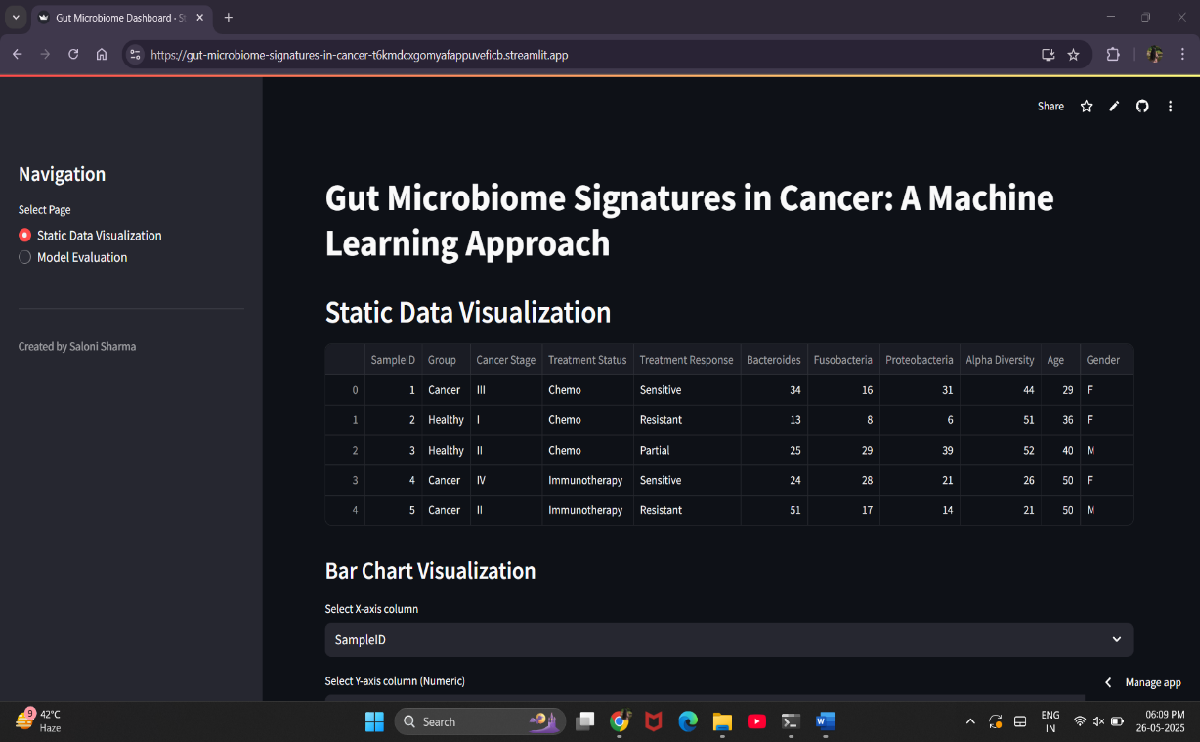

***Fig.01***

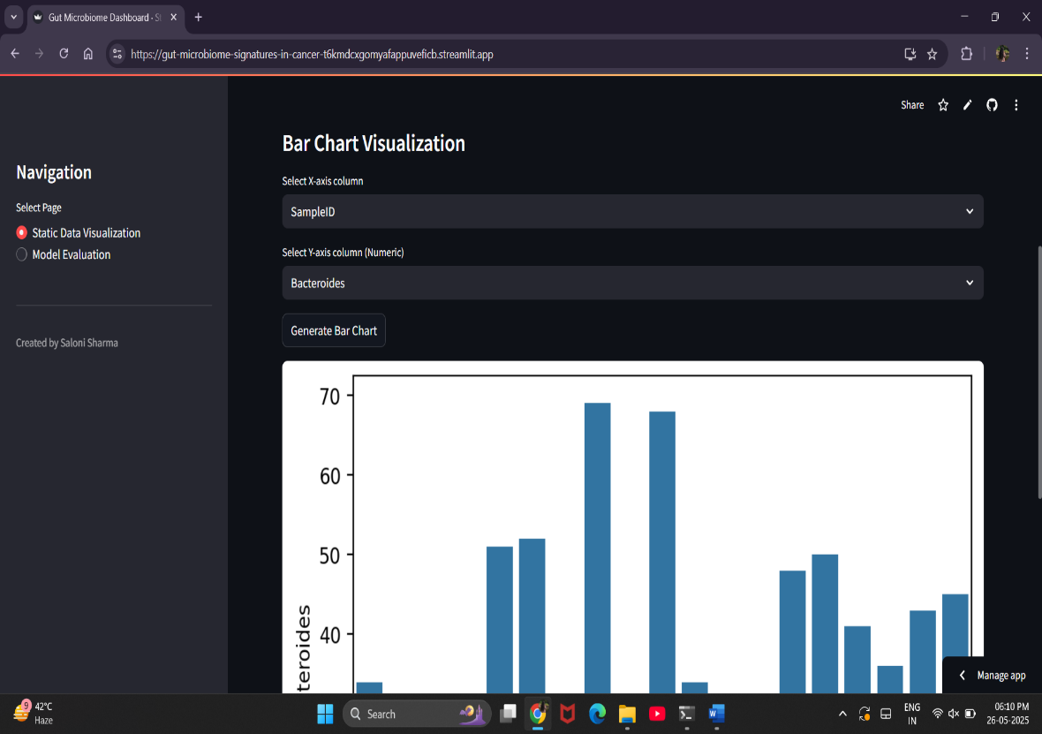

***Fig.02***

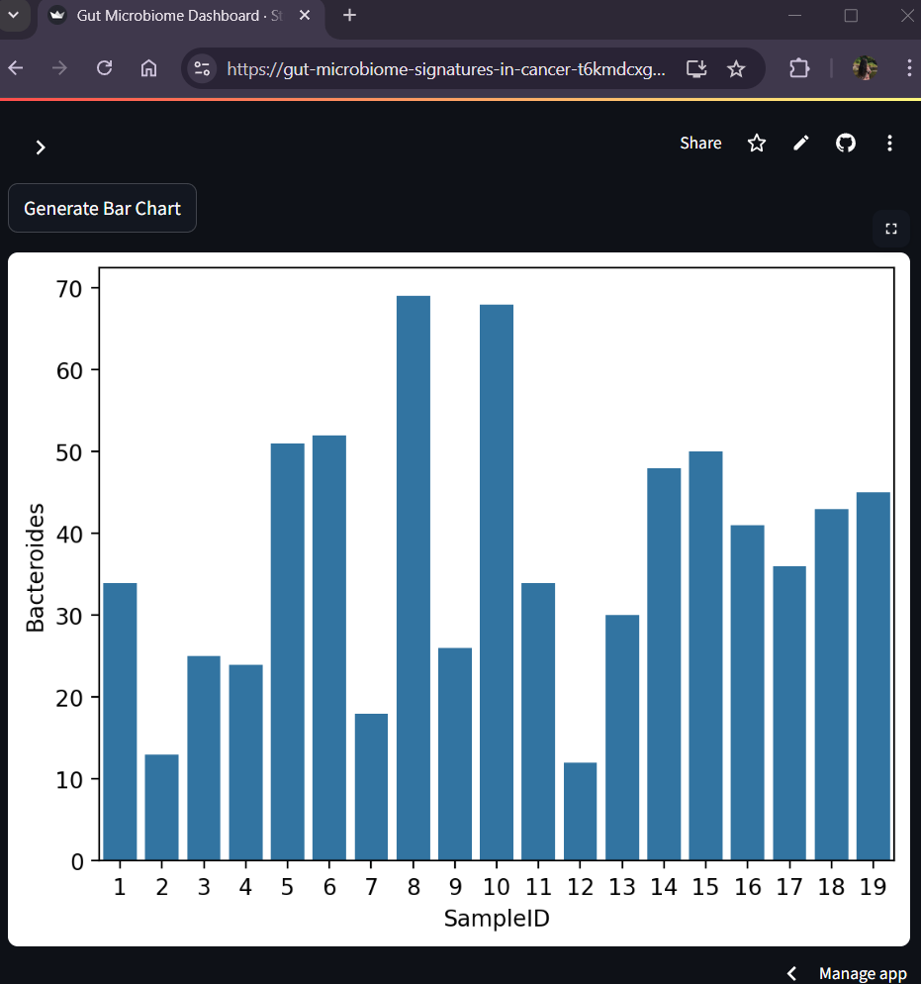

***Fig.03***



***Fig.04***



***Fig.05***

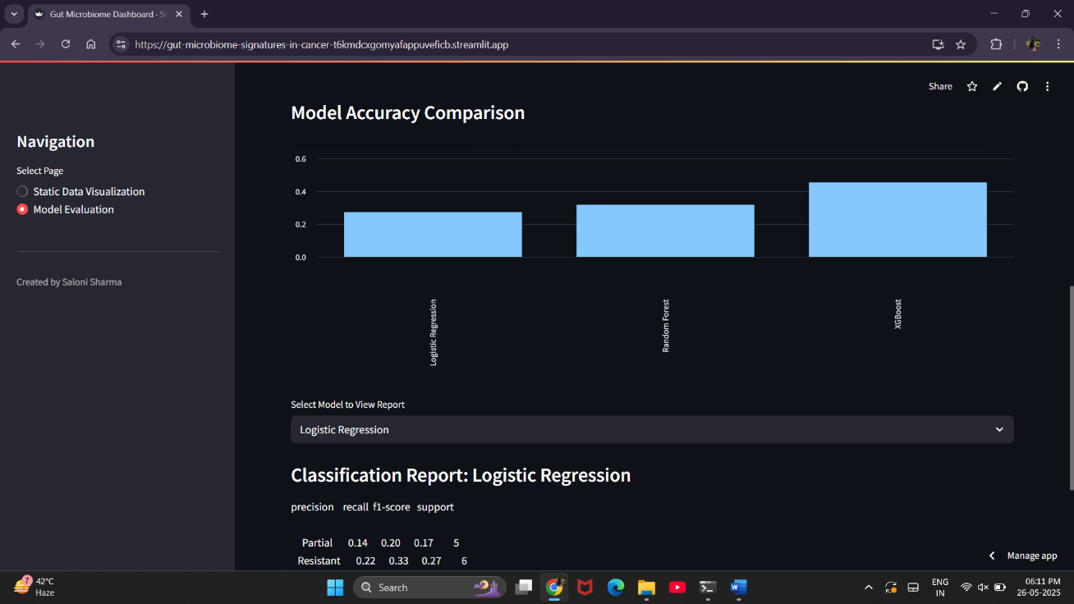

***Fig.06***

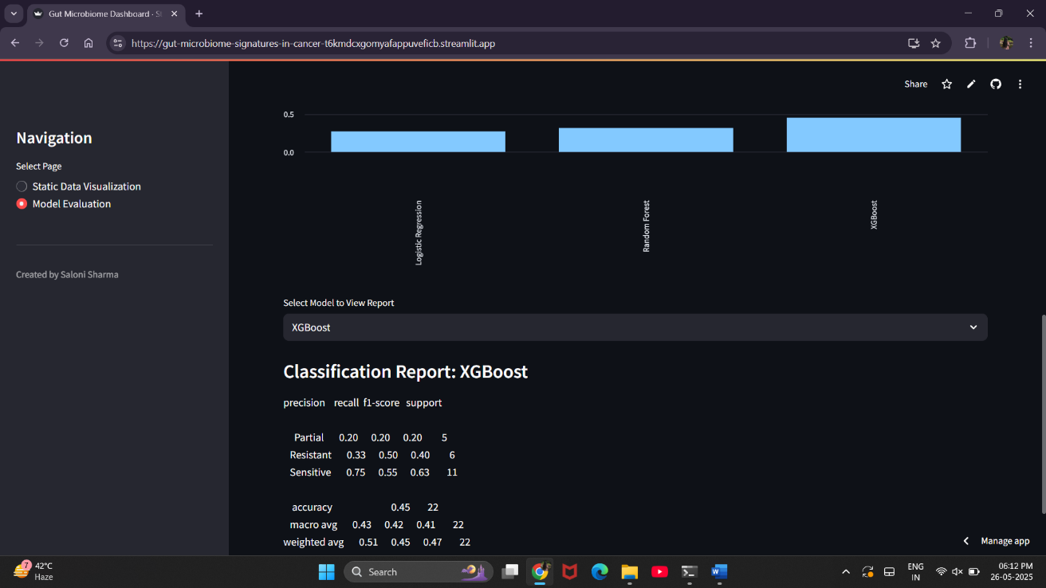

***Fig.07***

**References**

* Gopalakrishnan, V., et al. (2018). The Influence of the Gut Microbiome on Cancer, Immunity, and Cancer Immunotherapy. Cancer Cell, 33(4), 570–580. <https://doi.org/10.1016/j.ccell.2018.03.015>
* Routy, B., et al. (2018). Gut microbiome influences efficacy of PD-1–based immunotherapy against epithelial tumors. Science, 359(6371), 91-97. <https://doi.org/10.1126/science.aan3706>
* Pasolli, E., et al. (2016). Machine learning meta-analysis of large metagenomic datasets: tools and biological insights. PLoS Computational Biology, 12(7), e1004977. <https://doi.org/10.1371/journal.pcbi.1004977>
* Zitvogel, L., et al. (2017). Microbiome and anticancer immunosurveillance. Cell, 165(2), 276–287. <https://doi.org/10.1016/j.cell.2016.03.038>
* Topçuoğlu, B. D., et al. (2020). Framework for effective application of machine learning to microbiome-based classification problems. mBio, 11(3). https://doi.org/10.1128/mBio.00434-20

(Back Cover)

**SCHOOL OF COMPUTER APPLICATION AND TECHNOLOGY**

**CAREER POINT UNIVERSITY, KOTA**

Saloni Sharma

2025

**2025**

**Comparative Analysis of Crude Oil and Gas Production Using Various Machine Learning Models**

